Wash Zoom 19*40w moving head

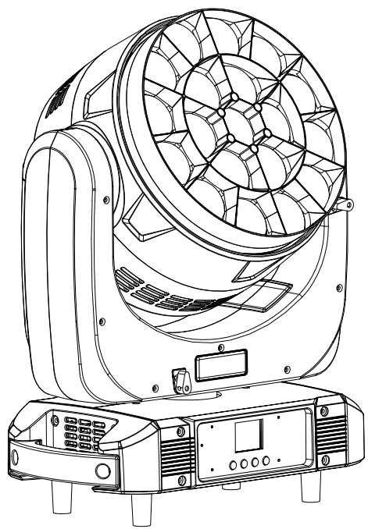

User manual
Please read the instructions carefully before us

TABLE OF CONTENTS

1. Safety Instructions ......................................................................................3 - 4

2. Technical Specifications 5

3. Lux date…………………………………………………………………………… 6

4. How To Control The Unit 6-9

5. DMX Channel List.....................................................................................9- 16

6. Shape.........................................................................................................................17

7.Trouble shooting.............................................................................................18

8.Fixture Cleaning.............................................................................................19

statement
The product has well capability and intact packing when leave factory. All of the user should comply with warning item and manual, any misuse cause of the damages are not included in our guarantee, and also can’t be responsible for any malfunction & problem owing to ignore the manual.

1. Safety Instructions
Please keep this User Guide for future consultation. If you sell the unit to another user, be sure that they also receive this instruction booklet.

-  Unpack and check carefully there is no transportation damage before using the unit.
-  Before operating, ensure that the voltage and frequency of power supply match the power requirements of the unit.
-  It’s important to ground the yellow/green conductor to earth in order to avoid electric shock.
-  The unit is for indoor use only. Use only in a dry location.
-  The unit must be installed in a location with adequate ventilation, at least 50 cm from adjacent surfaces. Be sure that no ventilation slots are blocked.
-  Disconnect main power before replacement or servicing.
-  Make sure there are no flammable materials close to the unit while operating as it is fire hazard.
-  Use safety cable when fixes this unit. Do not handle the unit by taking its head only, but always by taking its base.
-  Maximum ambient temperature is Ta: 40℃. Do not operate it where the temperature is higher than this Unit surface temperature may reach up to 85℃. Do not touch the housing bare-hand during its operation. Turn off the power and allow about 15 minutes for the unit to cool down before replacing or serving.
- the event of serious operating problem, stop using the unit immediately. Never try to repair the unit by yourself. Repairs carried out by unskilled people can lead to damage or malfunction. Please contact the nearest authorized technical assistance center. Always use the same type spare parts.
- Do not touch any wire during operation as high voltage might be causing electric shock.

Warning:

- To prevent or reduce the risk of electrical shock or fire, do not expose the unit to rain or moisture.
- Do not open the unit within five minutes after switching off.
- The housing, the lenses, or the ultraviolet filter must be replaced if they are visibly damaged.

Caution:
There are no user serviceable parts inside the unit. Do not open the housing or attempt any repairs yourself. In the unlikely event your unit may require service, please contact your nearest dealer.

Installation:
The unit should be mounted via its screw holes on the bracket. Always ensure that the unit is firmly fixed to avoid vibration and slipping while operating. And make sure that the structure to which you are attaching the unit is secure and is able to support a weight of 10 times of the unit’s weight. Also always use a safety cable that can hold 12 times of the weight of the unit when installing the fixture.

The equipment must be fixed by professionals. And it must be fixed at a place where is out of the touch of people.

2. Technical Specifications
Light Sources: 19*40W 4IN1 RGBW LED
Average life span> 50000 hours
Beam Angle:3.5°- 50°
Glass light guide + PMMA high quality optical lens
Power Consumption: 630w
Power factor PF≥0.95
Power Voltage: AC 100-240V, 50/60Hz
Dimension:376*280*420.5mm
Net Weight:14.5kgs
Carton package 1in1 size: 53.5*39*49.5cm
Gross Weight: 18Kgs
Flight Case 1in2 size: 97*46*64cm
Gross Weight: 61.5Kgs
Working temperature: -10℃～45℃

Control
DMX Channel:19/27 Channels
Control Modes: DMX512/mater-Slave/Auto Run/Music
Pan/Tilt
Pan: 540°/ 360°, Tilt: 270°
Pan/Tilt Resolution: 8/16 bit
Construction
Display:180° reversible 1.8 inch TFT colorful Display
Data In/Out socket: 3-pin & 5-pin XLR sockets
Power Socket: Power Con in/out
Protection Rating: IP20

Features
Circle control effects, 3 circle control.
High-efficiency optical system, wonderful flower effect plus zoom
Fan work speed auto adjustable with head temperature

Lux Date
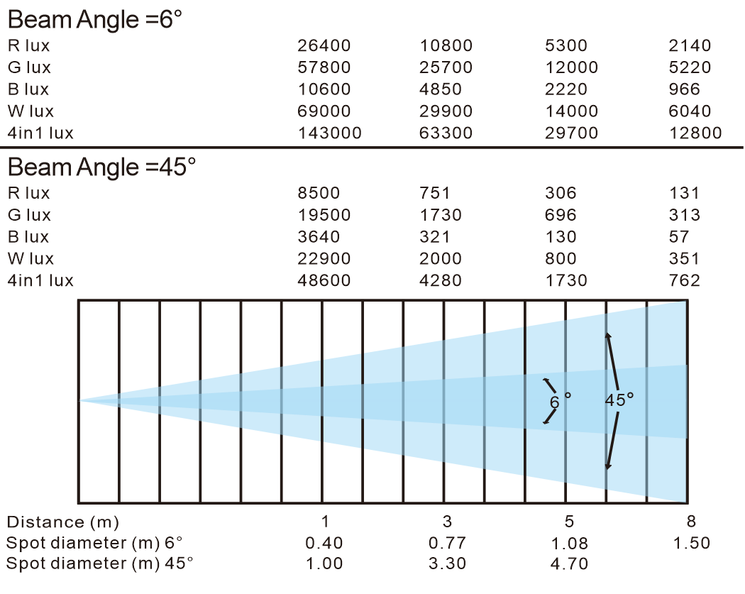

4. How To Control The Unit
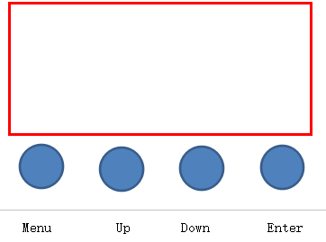
Display:

MENU To select the programming functions
DOWN To go backward in the selected functions
UP To go forward in the selected functions
ENTER To confirm the selected functions

Set DMX Address Code
1 Press "Menu" to "Set DMX Address", and press "ENTER" keys to enter into
2 Show "Set DMX Address DMX Address:001", Press the "UP and DOWN"
keys to amended
- Press "ENTER" keys to save and Exit, Press the "MENU" Keys does not save and Exit

Menu  Menu | 1.Pan Degree |  | - 540 °, 2)360° | X-axis running angle selection
Menu  Menu | 2.Mic Sense |  | 001 - 100 | Sound sensitivity adjustment
Menu  Menu | 3.Language |  | English | Chinese
Menu  Menu | 4.No Signal |  | 1.Black Out 2.Hold | Set the state when the machine has no signal input
Menu  Menu | 5.Fan Set |  | 1.Auto 2. Low 3.High | Set fan speed
Menu  Menu | 6.Reset |  | Yes | No
Menu  Menu | 7.Default |  | Yes | No
Menu  Menu | 8.Adjust  8.Adjust |  | Pass Word：****
Menu  Menu |  |  | Pan | 0 - 255
Menu  Menu |  |  | Tilt | 0 - 255
Menu  Menu |  |  | Focus | 0 - 255
Menu  Menu |  |  | Red | 0 - 255
Menu  Menu |  |  | Green | 0 - 255
Menu  Menu |  |  | Blue | 0 - 255
Menu  Menu |  |  | White | 0 - 255
Address | Setting from 001 - 512
Reverse | Forward or reversed setting |  | Pan | 1.Yes
Reverse |  |  | Pan | 2.No
Reverse |  |  | Tilt | 1.Yes
Reverse |  |  | Tilt | 2.No
Reverse |  |  | Display | 1.Yes
Reverse |  |  | Display | 2.No
Information |  |  | 1.CH Value | Each channel show CH value
 |  |  | 2.Temp ____℃ | Show the temperature of led board
 |  |  | 3.Soft V.XXX | Show the version number
Channel |  |  | 19 channels
 |  |  | 27 channels
Mode |  |  | DMX 512
 |  |  | AUTO
 |  |  | SOUND
 |  |  | Manual
Manual |  | Master | Pan：0--255 |  | Manual Control
 |  | Master | Tilt:0--255 |  | Manual Control
 |  | Master | Focus:0--255 |  | Manual Control
 |  | Master | Rota:0-255 |  | Manual Control
 |  | Master | Red：0--255 |  | Manual Control
 |  | Alone | Greed：0--255 |  | Manual Control
 |  | Alone | Blue：0--255 |  | Manual Control
 |  | Alone | White：0--255 |  | Manual Control
 |  | Alone | Strobe：0-255 |  | Manual Control

5.DMX Channel List
Model 1 - CH19
Channel | Display | Function | Value
CH-1 | Pan adjustment | Pan adjustment | 0 --- 255
CH-2 | Pan adjustment | Pan adjustment | 0 --- 255
CH-3 | Tilt adjustment | Tilt adjustment | 0 --- 255
CH-4 | Tilt adjustment | Tilt adjustment | 0 --- 255
CH-5 | Pan/Tilt speed | from fast to slow | 0 --- 255
CH-6 | Strobe | No | 0 --- 15
CH-6 | Strobe | From slow to fast | 16 --- 214
CH-6 | Strobe | Random strobe | 215 --- 255
CH-7 | Dimming | From dark to bright | 0 --- 255
CH-8 | Dimming Model | Model -1 | 0 --- 49
CH-8 | Dimming Model | Model -2 | 50 --- 99
CH-8 | Dimming Model | Model -3 | 100 --- 149
CH-8 | Dimming Model | Model -4 | 150 --- 255
CH-9 | Focus | from near to far | 0 --- 255
CH-10 | Red | From dark to bright  From dark to bright | 0 --- 255
CH-11 | Green | From dark to bright  From dark to bright | 0 --- 255
CH-12 | Blue | From dark to bright  From dark to bright | 0 --- 255
CH-13 | White | From dark to bright  From dark to bright | 0 --- 255
CH-14  CH-14 | Static color  Static color | No | 0----15
CH-14  CH-14 | Static color  Static color | R 100%,G up,B0% | 16----35
CH-14  CH-14 | Static color  Static color | R down,G 100%,B0% | 36----55
CH-14  CH-14 | Static color  Static color | R 0%, G 100%, B up | 56----75
CH-14  CH-14 | Static color  Static color | R 0%, G100%, B up | 76----95
CH-14  CH-14 | Static color  Static color | R up, G0%, B100% | 96----115
CH-14  CH-14 | Static color  Static color | R 100%, G0%, B down | 116----135
CH-14  CH-14 | Static color  Static color | R 100%, G up, B up | 136----155
CH-14  CH-14 | Static color  Static color | R 100%, G down, B 100% | 156----175
CH-14  CH-14 | Static color  Static color | R 100%, G 100%, B 100%, W 100% | 176----195
CH-14  CH-14 | Static color  Static color | 2800K | 196----200
CH-14  CH-14 | Static color  Static color | 3200K | 201----205
CH-14  CH-14 | Static color  Static color | 3500K | 206----210
CH-14  CH-14 | Static color  Static color | 4000K | 211----215
CH-14  CH-14 | Static color  Static color | 4500K | 216----220
CH-14  CH-14 | Static color  Static color | 5000K | 221----225
CH-14  CH-14 | Static color  Static color | 5500K | 226----230
CH-14  CH-14 | Static color  Static color | 6000K | 231----235
CH-14  CH-14 | Static color  Static color | 6500K | 236----240
CH-14  CH-14 | Static color  Static color | 7000K | 241----245
CH-14  CH-14 | Static color  Static color | 7500K | 246----250
CH-14  CH-14 | Static color  Static color | 8000K | 251----255
CH-15 | Effects | No | 0 ---- 9
CH-15 | Effects | 3 numbers 1 effect | 10 --- 99
CH-15 | Effects | Jump | 100 --- 149
CH-15 | Effects | gradual change | 150 --- 255
CH-16 | Zone | No | 0 --- 19
CH-16 | Zone | Zone -1 | 20 --- 39
CH-16 | Zone | Zone -2 | 40 --- 59
CH-16 | Zone | Zone -3 | 60 --- 79
CH-16 | Zone | Zone -4 | 80 --- 99
CH-16 | Zone | Zone -5 | 100 --- 119
CH-16 | Zone | Zone -6 | 120 --- 139
CH-16 | Zone | Zone -7 | 140 --- 159
CH-16 | Zone | Zone-8 | 160 --- 179
CH-16 | Zone | Zone -9 | 180 --- 199
CH-16 | Zone | Zone -10 | 200 --- 219
CH-16 | Zone | Zone -11 | 220 --- 255
CH-17 | Zone change speed | Zone 7 --- Zone 11 | 0 --- 255
CH-18 | Zone change fade | Zone 7 --- Zone 11 | 0 --- 255
CH-19 | Reset | No | 0 --- 79
CH-19 | Reset | Reset | 80 --- 99
CH-19 | Reset | No | 100 --- 255

Model 2 - CH27

Channel | Display | Function | Value
CH-1 | Pan adjustment | Pan adjustment | 0 --- 255
CH-2 | Pan adjustment | Pan adjustment | 0 --- 255
CH-3 | Tilt adjustment | Tilt adjustment | 0 --- 255
CH-4 | Tilt adjustment | Tilt adjustment | 0 --- 255
CH-5 | Pan/Tilt speed | from fast to slow | 0 --- 255
CH-6 | Strobe | No | 0 --- 15
CH-6 | Strobe | From slow to fast | 16 --- 214
CH-6 | Strobe | Random strobe | 215 --- 255
CH-7 | Dimming | From dark to bright | 0 --- 255
CH-8 | Dimming Model | Model -1 | 0 --- 49
CH-8 | Dimming Model | Model -2 | 50 --- 99
CH-8 | Dimming Model | Model -3 | 100 --- 149
CH-8 | Dimming Model | Model -4 | 150 --- 255
CH-9 | Focus | from near to far | 0 --- 255
CH-10 | Red-1 | From dark to bright  From dark to bright | 0 --- 255
CH-11 | Green-1 | From dark to bright  From dark to bright | 0 --- 255
CH-12 | Blue-1 | From dark to bright  From dark to bright | 0 --- 255
CH-13 | White-1 | From dark to bright  From dark to bright | 0 --- 255
CH-14 | Red-2 | From dark to bright  From dark to bright | 0 --- 255
CH-15 | Green-2 | From dark to bright  From dark to bright | 0 --- 255
CH-16 | Blue-2 | From dark to bright  From dark to bright | 0 --- 255
CH-17 | White-2 | From dark to bright  From dark to bright | 0 --- 255
CH-18 | Red-3 | From dark to bright  From dark to bright | 0 --- 255
CH-19 | Green-3 | From dark to bright  From dark to bright | 0 --- 255
CH-20 | Blue-3 | From dark to bright  From dark to bright | 0 --- 255
CH-21 | White-3 | From dark to bright  From dark to bright | 0 --- 255
CH-22  CH-22 | Static color  Static color | No | 0----15
CH-22  CH-22 | Static color  Static color | R 100%, G up, B0% | 16----35
CH-22  CH-22 | Static color  Static color | R down, G 100%, B0% | 36----55
CH-22  CH-22 | Static color  Static color | R 0%, G 100%, B up | 56----75
CH-22  CH-22 | Static color  Static color | R 0%, G100%, B up | 76----95
CH-22  CH-22 | Static color  Static color | R up, G0%, B100% | 96----115
CH-22  CH-22 | Static color  Static color | R 100%, G0%, B down | 116----135
CH-22  CH-22 | Static color  Static color | R 100%,G up, B up | 136----155
CH-22  CH-22 | Static color  Static color | R 100%, G down, B 100% | 156----175
CH-22  CH-22 | Static color  Static color | R 100%, G 100%, B 100%, W 100% | 176----195
CH-22  CH-22 | Static color  Static color | 2800K | 196----200
CH-22  CH-22 | Static color  Static color | 3200K | 201----205
CH-22  CH-22 | Static color  Static color | 3500K | 206----210
CH-22  CH-22 | Static color  Static color | 4000K | 211----215
CH-22  CH-22 | Static color  Static color | 4500K | 216----220
CH-22  CH-22 | Static color  Static color | 5000K | 221----225
CH-22  CH-22 | Static color  Static color | 5500K | 226----230
CH-22  CH-22 | Static color  Static color | 6000K | 231----235
CH-22  CH-22 | Static color  Static color | 6500K | 236----240
CH-22  CH-22 | Static color  Static color | 7000K | 241----245
CH-22  CH-22 | Static color  Static color | 7500K | 246----250
CH-22  CH-22 | Static color  Static color | 8000K | 251----255
CH-23 | Effects | No | 0 ---- 9
CH-23 | Effects | 3 numbers 1 effect | 10 --- 99
CH-23 | Effects | Jump | 100 --- 149
CH-23 | Effects | gradual change | 150 --- 255
CH-24  CH-24 | Zone  Zone | No | 0 --- 19
CH-24  CH-24 | Zone  Zone | Zone -1 | 20 --- 39
CH-24  CH-24 | Zone  Zone | Zone -2 | 40 --- 59
CH-24  CH-24 | Zone  Zone | Zone -3 | 60 --- 79
CH-24  CH-24 | Zone  Zone | Zone -4 | 80 --- 99
CH-24  CH-24 | Zone  Zone | Zone -5 | 100 --- 119
CH-24  CH-24 | Zone  Zone | Zone -6 | 120 --- 139
CH-24  CH-24 | Zone  Zone | Zone -7 | 140 --- 159
CH-24  CH-24 | Zone  Zone | Zone -8 | 160 --- 179
CH-24  CH-24 | Zone  Zone | Zone -9 | 180 --- 199
CH-24  CH-24 | Zone  Zone | Zone -10 | 200 --- 219
CH-24  CH-24 | Zone  Zone | Zone -11 | 220 --- 255
CH-25 | Zone change speed | Zone 7 --- Zone 11 | 0 --- 255
CH-26 | Zone change fade | Zone 7 --- Zone 11 | 0 --- 255
CH-27 | Reset | No | 0 --- 79
CH-27 | Reset | Reset | 80 --- 99
CH-27 | Reset | No | 100 --- 255

6. Shape
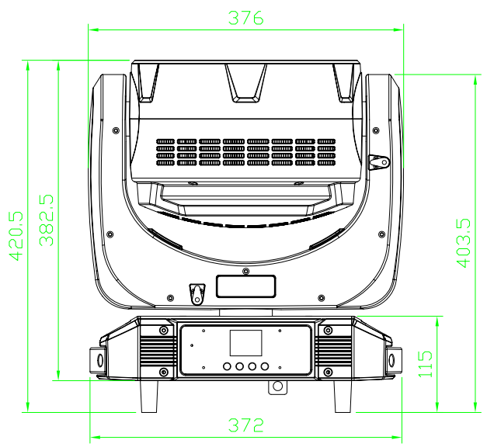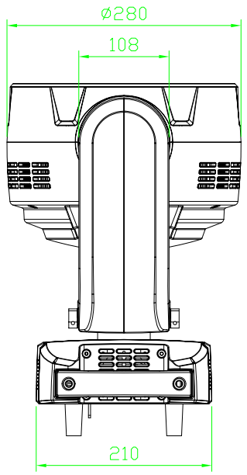

7. Trouble shooting
Following are a few common problems that may occur during operation. Here are some suggestions for easy troubleshooting:

A. The unit does not work, no light and the fan does not work
1. Check the connection of power and main fuse.
2. Measure the mains voltage on the main connector.
3. Check the power on LED.

B. Not responding to DMX controller
1. DMX LED should be on. If not, check DMX connectors, cables to see if link properly.
2. If the DMX LED is on and no response to the channel, check the address settings and DMX polarity.
3. If you have intermittent DMX signal problems, check the pins on connectors or on
PCB of the unit or the previous one.
4. Try to use another DMX controller.
5. Check if the DMX cables run near or run alongside to high voltage cables that may cause damage or interference to DMX interface circuit.
C. One of the channels is not working well
1. The stepper motor might be damaged or the cable connected to the PCB is broken.
2. The motor’s drive IC on the PCB might be out of condition.

8. Fixture Cleaning
The cleaning of internal and external optical lenses and/or mirrors must be carried out periodically to optimize light output. Cleaning frequency depends on the environment in which the fixture operates: damp, smoky or particularly dirty surrounding can cause greater accumulation of dirt on the unit’s optics.
• Clean with soft cloth using normal glass cleaning fluid.
• Always dry the parts carefully.
• Clean the external optics at least every 20 days. Clean the internal optics at least every 30/60 days.

