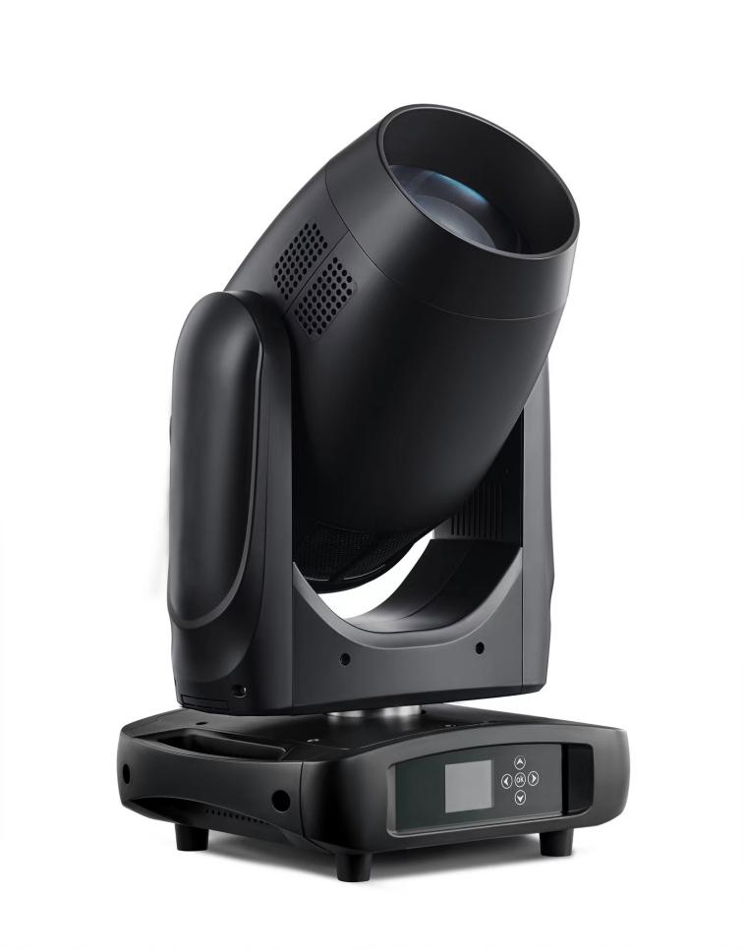

**Main technical parameters of the product:**

**Light Source:**

Bulb Specification: Philips MSD Silver 380W/2 LL

Color temperature: 7800K

Rated life: 4000 hours

**color:**

3color wheels 12colors+ OpenWhite (Including: CTO 3500K & UV)

Full CMY Color Mixing

**GOBOs:**

GOBO Wheel 1: 10Fixed + Open (1 Beam Reducers Beam Mode)

GOBO Wheel 2: 7Rotating/Replaceable + Open (Size: 15.9mm; Viewable: 11.5mm)

Modular design for easy servicing and GOBO replacement

**Effects:**

Prism: 1 8 prism,1 16 prism can be quickly cut in, cut out. It can be rotated in two directions with variable speed Two prisms can be stacked

Atomization: 1 single-sided high-transmission atomized lens

focusing: DMX linear focus

Strobe:Independent dual-chip. 0-15 times/second ultra-high-speed strobe. 0-100% linear dimming

Dimming: Linear Dimming

Zoom Range: 2 ~ 45-degrees

**Control:**

Rotation angle: 540° in the horizontal direction, 270° in the vertical direction, with automatic return function

Control Channels: 21, 24 or 26

DMX Modes: 2, RDM (Remote Device Management)

Control: 3-pin

Full color display menu

Pan/Tilt Speed: Fast to Slow

**Electrical:**

Input voltage: 110V~240V AC, 50/60Hz(Auto Sensing)

Daisy chain max: 3 fixtures (@120V); 5 fixtures (@230V)

Power Draw: 500W (4.71A @ 120V; 2.26A @ 220V)

**cooling system:**

Equipped with 9 cooling fans. After the bubble is eliminated for one minute, the fan will enter the silent cooling mode

**Other functions:**

Display lamp, bulb usage time. Remote control bulb switch function,Fault detection reminder, manual lock screen.

**Shell and protection grade:**

Aluminum, high temperature/UV resistant engineering plastic, protection grade IP20

**Dimensions/Weight:**

Dimensions (LxWxH): 14.8” x 11.6” x 23.5” / 382 x 299 x 603mm

Weight: 45 lbs. / 20.5 kg.